Position Vacancy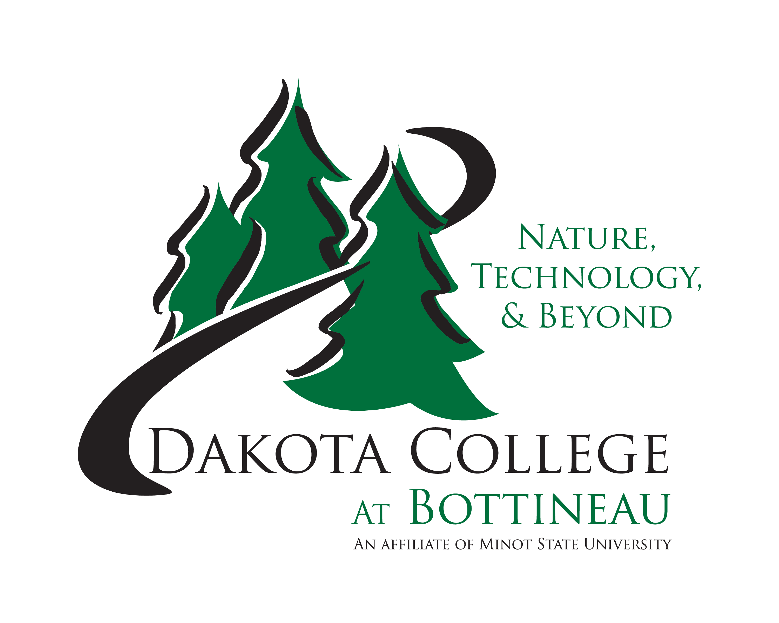
Accountant

Fulltime, Benefited Position

Dakota College at Bottineau is searching for an Accountant. This position is in the Business Office. The accountant will be responsible for initiating, processing, and coordinating campus fund accounting, assisting Director of Business Affairs with budgets, system reporting and analysis.

Specific duties:
- Credit cards – set up, balance, and monitor credit card expenses for the campus
- Reconcile Financial Aid reports to GL
- Vendor Creation – collect documentation and enter new vendors into the system
- Assist with researching budget discrepancies
- Assist with educating budget signatories on policies and procedures for budgeting and monitoring their respective budgets
- Approve purchase orders and expense reports
- Audit expenditures
- Prepare journal entries
- Review transaction postings for accuracy
- Audit receipts and keep track of till fund
- Prepare cash transfers on a timely basis
- Complete collection reports and submit collections to Bank of North Dakota
- Prepare bank reconciliations
- Work with collection agencies
- Assist with GL reconciliations
- Assist with expenditure research
- Collaborative Students – billing and charges
- Unclaimed property reconciliation and reporting
- Interdepartmental billings

Specific skills:
- Skill with accounting concepts
- Experience with Excel
- Experience with Microsoft Word
- Experience with PeopleSoft – preferred but not required

Qualifications: Business degree/accounting preferred. Experience with financial reporting, annual budgets, and reconciliations, credit cards.

Screening of applicants will continue until a suitable candidate is found.

Salary will be commensurate with experience.

Starting Date: ASAP

Applications may be obtained at http://www.dakotacollege.edu/employment.forms or at the Dakota College at Bottineau Business Office. Please return completed application, letter of application, resume, college transcripts and three work references to
Search Committee: Accountant
Dakota College at Bottineau
105 Simrall BLVD
Bottineau, ND 58318
or
Email: dcbhuman.resources@dakotacollege.edu
OR APPLY ONLINE AT: http://www.dakotacollege.edu/faculty-and-staff/employment/

Dakota College at Bottineau is an equal opportunity institution.

